39.48: a) 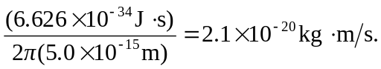
b)
c) The result of part (b), about 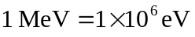, is many orders of magnitude larger than the potential energy of an electron in a hydrogen atom.

